Midterm II

Fall 2018

Due: Wednesday, November 14, 2018

##### 1. First write code that loads the workspace “Midterm II.RData”. This should read five different tibbles into your workspace.

##### 2. Write code that recreates the tibbles “player” and “player_attributes” by importing the files “player.csv” and “player_attributes.csv”. Compare the tibbles that you create with those in the Midterm II workspace to make sure that they are identical.

##### 3. Write code that recreates the season factor variable in the player_attributes tibble. Season is defined as the year from the match_date variable. Make sure your code converts your variable into a factor.

##### 4. Write code that creates the following bar chart:

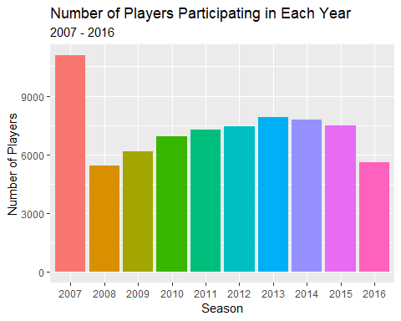

##### 5. Explain the code in the script file that creates the following graph:

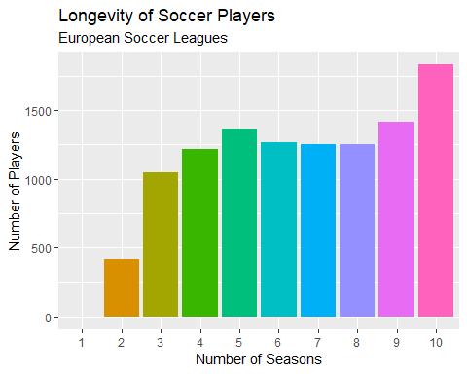

##### 6. Write a function named age that will create a variable age for each player based on the birthday of the player and the day of the match.

##### 7. Interpret the code in the script file that creates the tibble player_attributes_complete.

##### 8. Recreate the player_attributes_2106 tibble and then create the violin plot for the players who participated in the 2016 season.

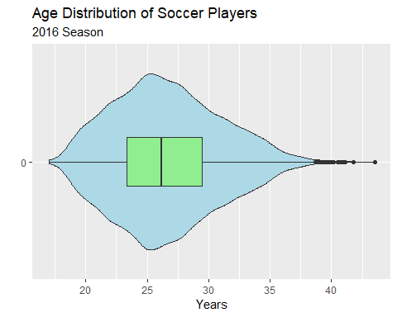

##### 9. Explain the code in the script file that creates the following graph:

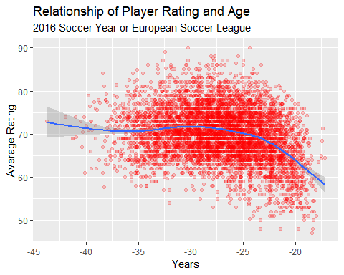

##### 10. Interpret the following code in the script file that compares the time series for average age and average rating.

